Checklist LaneLED INOX42
Quotation Order
Contact Details
Customer: | Consultant: | Project:
Customer-No.: | Contact person: | Delivery date:

Calculation for: Pathway Stairway
Project description:

Consultant involved: yes no
Existing quotation? yes no
Desired LaneLED type: cold white approx. 5'500 K comfort white approx. 4'000 – 4'400 K
Feed-in cable lenght: .......... m (mention exact feed-in point in sketch)
Placement: indoor outdoor
private installation public installation
Surface type concrete asphalt wood
(installation ground): …………………… isolation (outdoor wall)
Ligting requirement: ........... lx

Min. luminance intensity according to DIN EN12464-1:
- Pedestrian undercrossing with low number of persons: 50lx
- Pedestrian undercrossing with high number of persons, stairways, corridors, traffic zones: 100lx but depending on the exact utilisation of the corresponding room

CAD-Files available:
DXF-file
DWG-file

Comments:

Attachement: Pictures Sketches

Stairway (hand rail on the wall):
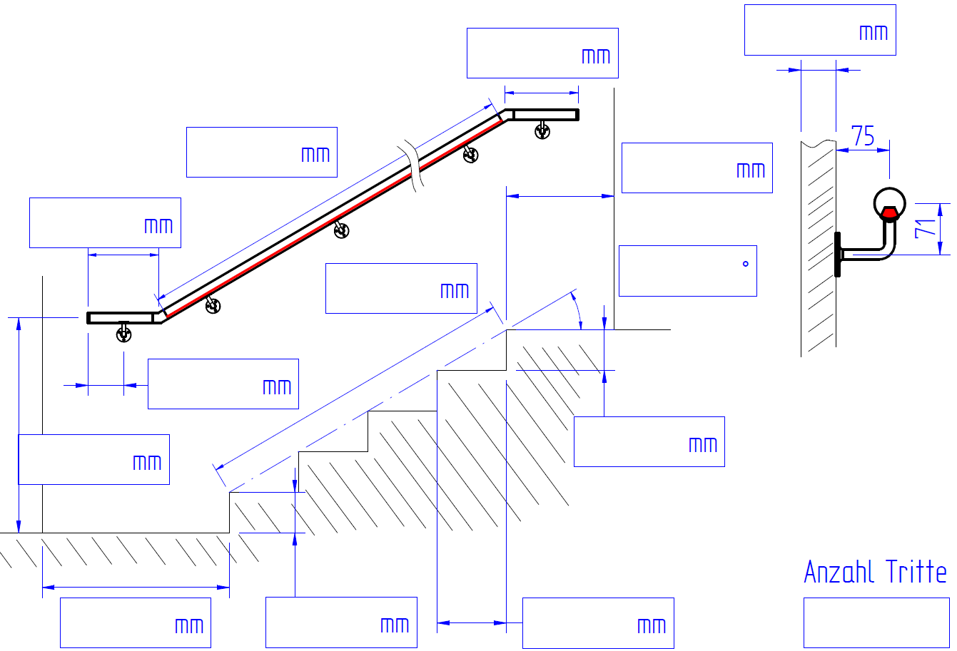
Stairway (hand rail on poles):
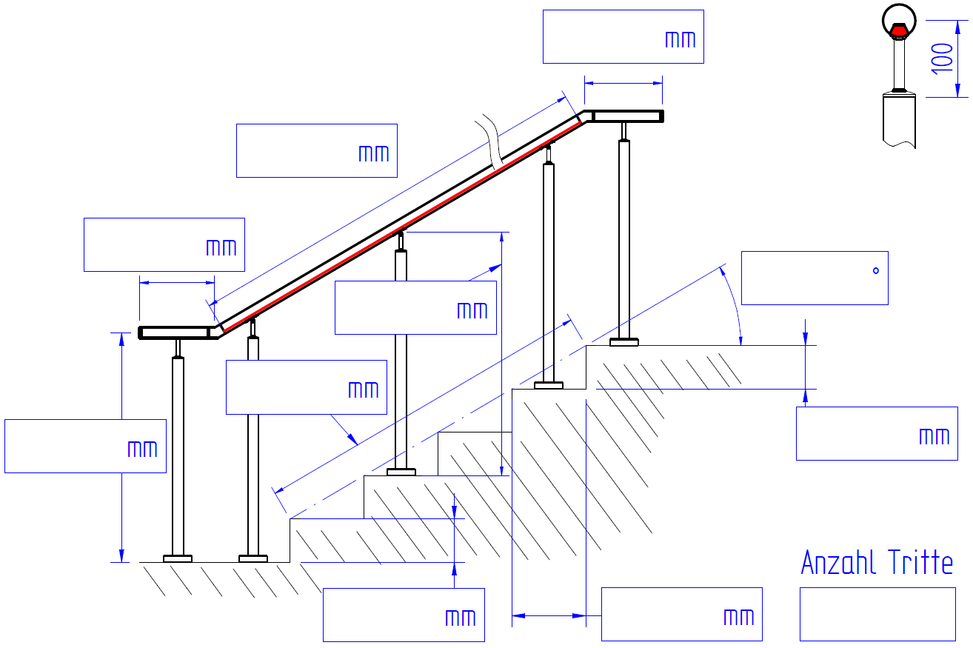
Pathway (hand rail on poles):
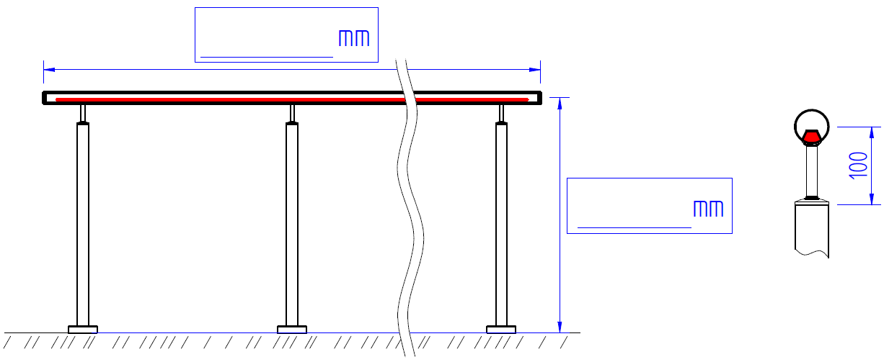
Pathway (hand rail on top of balustrade):
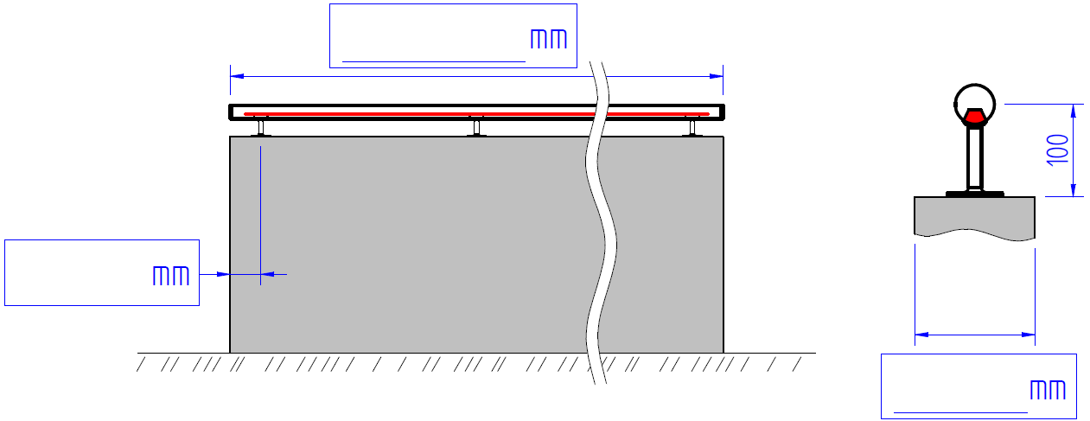
Pathway (hand rail on wall):
